2026 Hawk Girls Golf Invite

DATE: Thursday, April 2, 2026

TIME: 4:15 pm

LOCATION: Diamond Trail Golf Course, 9364 E 146th St S, Lynnville, IA 50153

TEAMS: Eddyville-Blakesburg-Fremont, PCM, Pella, Lynnville-Sully

ENTRY FEE: $90, Checks payable to Lynnville-Sully Coed Athletics

COACHES MEETING: There will be a coaches meeting at 3:55 pm in the clubhouse

ROSTERS: Please send your line-ups to Coach Hamborg ASAP- hamborg@lshawks.com. We are using Kodiak for scoring, so please have your students register on the Kodiak App prior to the start of the meet.

FORMAT: 9 holes, bring 6 varsity players, top 4 scores will count

RESULTS/AWARDS:
- Medals for top Individual Scorers
- 9 holes played, top 4 scores count for team standings
- Team tie for 1st, 2nd or 3rd, will go to 5th score, then 6th score
- 1st place medalist tie, will have a sudden death play off (hole-by-hole) starting on hole #1
- Tie for 2nd-10th place will card back starting on #1 handicap hole

RULES: IHSAA/IGHSAU/ USGA Rules of Golf

FOOD: available for purchase in the clubhouse

BATHROOMS: located in the clubhouse

WEATHER- Please email the phone number of your head coach and anticipated leave time in the event there is bad weather. hamborg@lshawks.com and parkinson@lshawks.com

- Winter Rules - pick, clean, and place; may move ball with club had 6 in. no closer to hole.
- Out of bounds is marked by white states, lines, or fences.
- Hazards are staked by yellow and red.
- All staked trees - free relief – 2 club lengths no closer to the hole. No relief from bushes.
- Distance yard markers are red-100, yellow-150, and blue-200
- Tee markers: Men’s- White | Women’s- Red.

Hole Information

- The road is out of bounds. Hitting the wire is re-hit with no penalty or play the ball where it lies. Creek- is a hazard marked with yellow lines. Out of bounds is also over the creek (right of the green) and marked with white stakes.

- The pond is considered a lateral water hazard and is marked with red stakes. The hole has a sand trap short of the green and in front of the green.

- A pond over the green is considered a lateral water hazard and marked with a red line or stake.

- Out of bounds on the right side of the hole marked by white stakes. The fence along the hole is also out of bounds. No free relief from out-of-bounds fence. The hole has a sand trap on top of the hill before the dogleg.

- Out of bounds on the right side of the hole marked by white stakes. The timber behind the hole is out of bounds, marked with white stakes.

- The fence on the left and over the green is out of bounds—no free relief from the fence. There are 2 sand traps on the right-hand side of the fairway about halfway to the green.

- The trees on the left of the hole are out of bounds. Also to the left and behind the green are out of bounds and marked by white stakes.

- Out of bounds is the timber behind the hole, marked with white stakes

- Creek- is a hazard marked by yellow stakes. Out of bounds is marked by white stakes on the right side of the fairway. Hitting the wire – re-hit with no penalty or play the ball where it lies.

https://diamondtrailgolfclub.com/

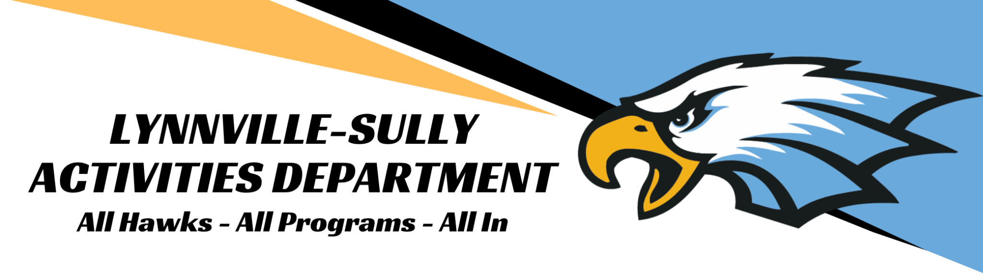
 |  |  |  | INVOICE
 | Payable To
 | Lynnville-Sully Activities
 | c/o Susan Jansen
 | PO Box 210 |  |  | Lynnville-Sully Activities Office
 | Sully, IA 50251 |  |  | 12476 Hwy F-62 E / PO Box 210
 |  |  |  |  |  | Sully, IA 50251
 |  |  |  |  |  | 641-594-4445
Event Date |  | Item |  |  |  |  | Event Fee
4/2/26 |  | Lynnville-Sully Golf
 |  | Greens Fees / Course Fees |  |  |  |  | $90.00
 |  | $90 per team

Thank you for attending our annual meet!

Mike Parkinson
Lynnville-Sully AD
parkinson@lshawks.com
641-594-4445 ext 1017

