
Track Coaches,
We welcome you to the 2026 Middle School Conference Track Meet @ Chariton on Friday, May 8th, 2026. Below is important information related to the meet. If you have any questions regarding entries, please contact Brett Carney @ BrettCarney10@gmail.com . If you have questions about the meet itself, please contact tim.milledge@chariton.k12.ia.us .
Entries and Results:
- Entries will be completed by coaches at the following site: www.athletic.net
- Entries will close at 8:00PM on Thursday, May 7th.
- You may enter (4) individuals for each event, but only (2) will score.
- You may enter (2) teams for each relay, but only (1) will score.
- If you have ANY questions regarding entries, please contact BrettCarney10@gmail.com
- All American Timing will provide timing services, and results will be LIVE at www.AATiming.com

Spectator Information:
- Address of complex: 1100 North 16th Street, Chariton
- Admission: $5 for students and adults-SCC passes accepted-CASH OR CREDIT/DEBIT accepted
- Concessions: FULL concessions available
- Restrooms: Located in the concessions building in the SW corner of the complex and in the North locker room facility
Meet Information:
- Field Events will start at 4:00pm. Running Events will start at 4:45pm.
- We will have two starters: Jeff Cook and Rich Choponis
- Awards will be ready to pick up at the conclusion of the meet from the press box.
  - Individual Events-Medals for 1st-3rd
  - Relay Events-Medals for 1st- 2nd
  - Team Champions: Championship plaques awarded to winning schools—Please remember that this is a combined 7/8 meet for boys and girls-one boys champion, one girls champion.
- Boys and girls scoring will be the same for individual and relay events.
  - 8 places-10-8-6-5-4-3-2-1
- Lanes and heats will be seeded running slow to fast.
- The order of events has been established by the IHSAA/IGHSAU (see below)
- Field Event Specifics:
  - High Jump: Girls, then boys (Girls-3’8”, Boys-4’4”)
  - Shot Put: Boys, then girls. Each competitor will get 3 throws-all finals-cafeteria style.
  - Long Jump: Boys, then girls. 3 Jumps, all finals.
  - Discus: Girls, then boys. Each competitor will get 3 throws-all finals-cafeteria style.
  - Athletes who excuse themselves from a field event to run will be allowed a maximum of 15 minutes to return to the field event. An athlete can request to go earlier in the sequence if they know they are going to be running an early event.
- Team camps are to be established outside of the track and not on the field
Miscellaneous Information:
- Please drop student athletes off at the south entrance to Reynolds Field/Bob Cain Track and then park directly south of the complex in the city maintenance lot or Armory parking lot.
- In the event of inclement weather, teams will be directed to go to the Armory or Locker Rooms at Reynolds Field.

Order of Events:
4:00 Shot Put (Boys/Girls)
Discus (Girls/Boys)
High Jump (Girls- start at 3’8” & Boys- start at 4’4”)
Long Jump (Boys/Girls)

4:45 4x800 Meter Relay
Shuttle Hurdle Relay
100 Meter Dash
1600 Dis-Medley Relay
400 Meter Dash
4x200 Meter Relay
1500 Meter Run (Girls)
1600 Meter Run (Boys)
100 M Hurdles
200 Meter Dash
800 Sprint Medley Relay
200 Meter Hurdles
800 Meter Run
4x100 Meter Relay
4x400 Meter Relay

Reynolds Field/Bob Cain Track
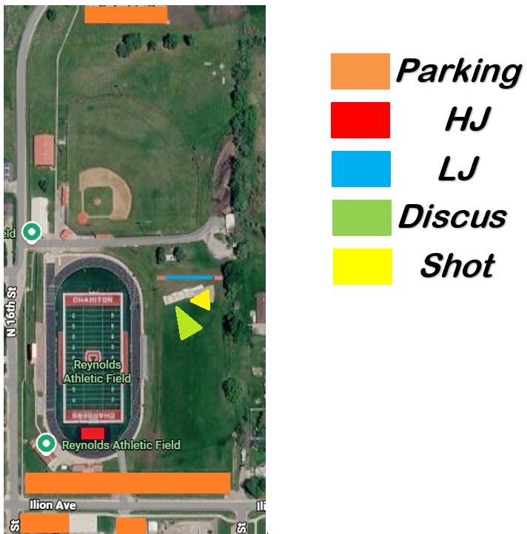

We are excited to host you all on May 8th!
Let me know if you have questions-
Tim Milledge
Activities Director/Assistant Principal
Chariton High School
Tim.milledge@chariton.k12.ia.us

