

Date: Thursday, April 23, 2026
Time: 4:00 - Field Events and 4:45 - Running Events
Location: Lac qui Parle Valley High School Track and Field
Schools: LqPV-DB, BOLD, CMCS, Hancock, Lakeview, MACCRAY/RCW, Montevideo, Morris Area, Ortonville, and YME
Entry Fee: NONE - All entry fees are being waived
Starter: Mark Ekren
Athletic Trainer: Kelly Wittnebel - Big Stone Therapies
Registration: Invitations will be sent to you via athletic.net. Please accept and enter your individual athletes to each event. This meet is being run/timed by Josh Gerber and Wayzata Results.
Entry Limits: 5 entries per event and 1 relay team
Awards: Event Champions will receive a t-shirt for their first place finish. Ribbons will be awarded to the 2nd and 3rd place finishers.
Other Important Information:
- No Shots or Discus allowed inside fenced area (track & football field)
- All camps will be outside the football field
- No Footballs or anything else that will be thrown around
Food/Drink:
- Athletes will be tread to food/beverage when they arrive
- We will have a coach’s hospitality room with food/drink up in the press box - ONLY AVAILABLE TO COACHES AND EVENT WORKERS
- Concessions will be available


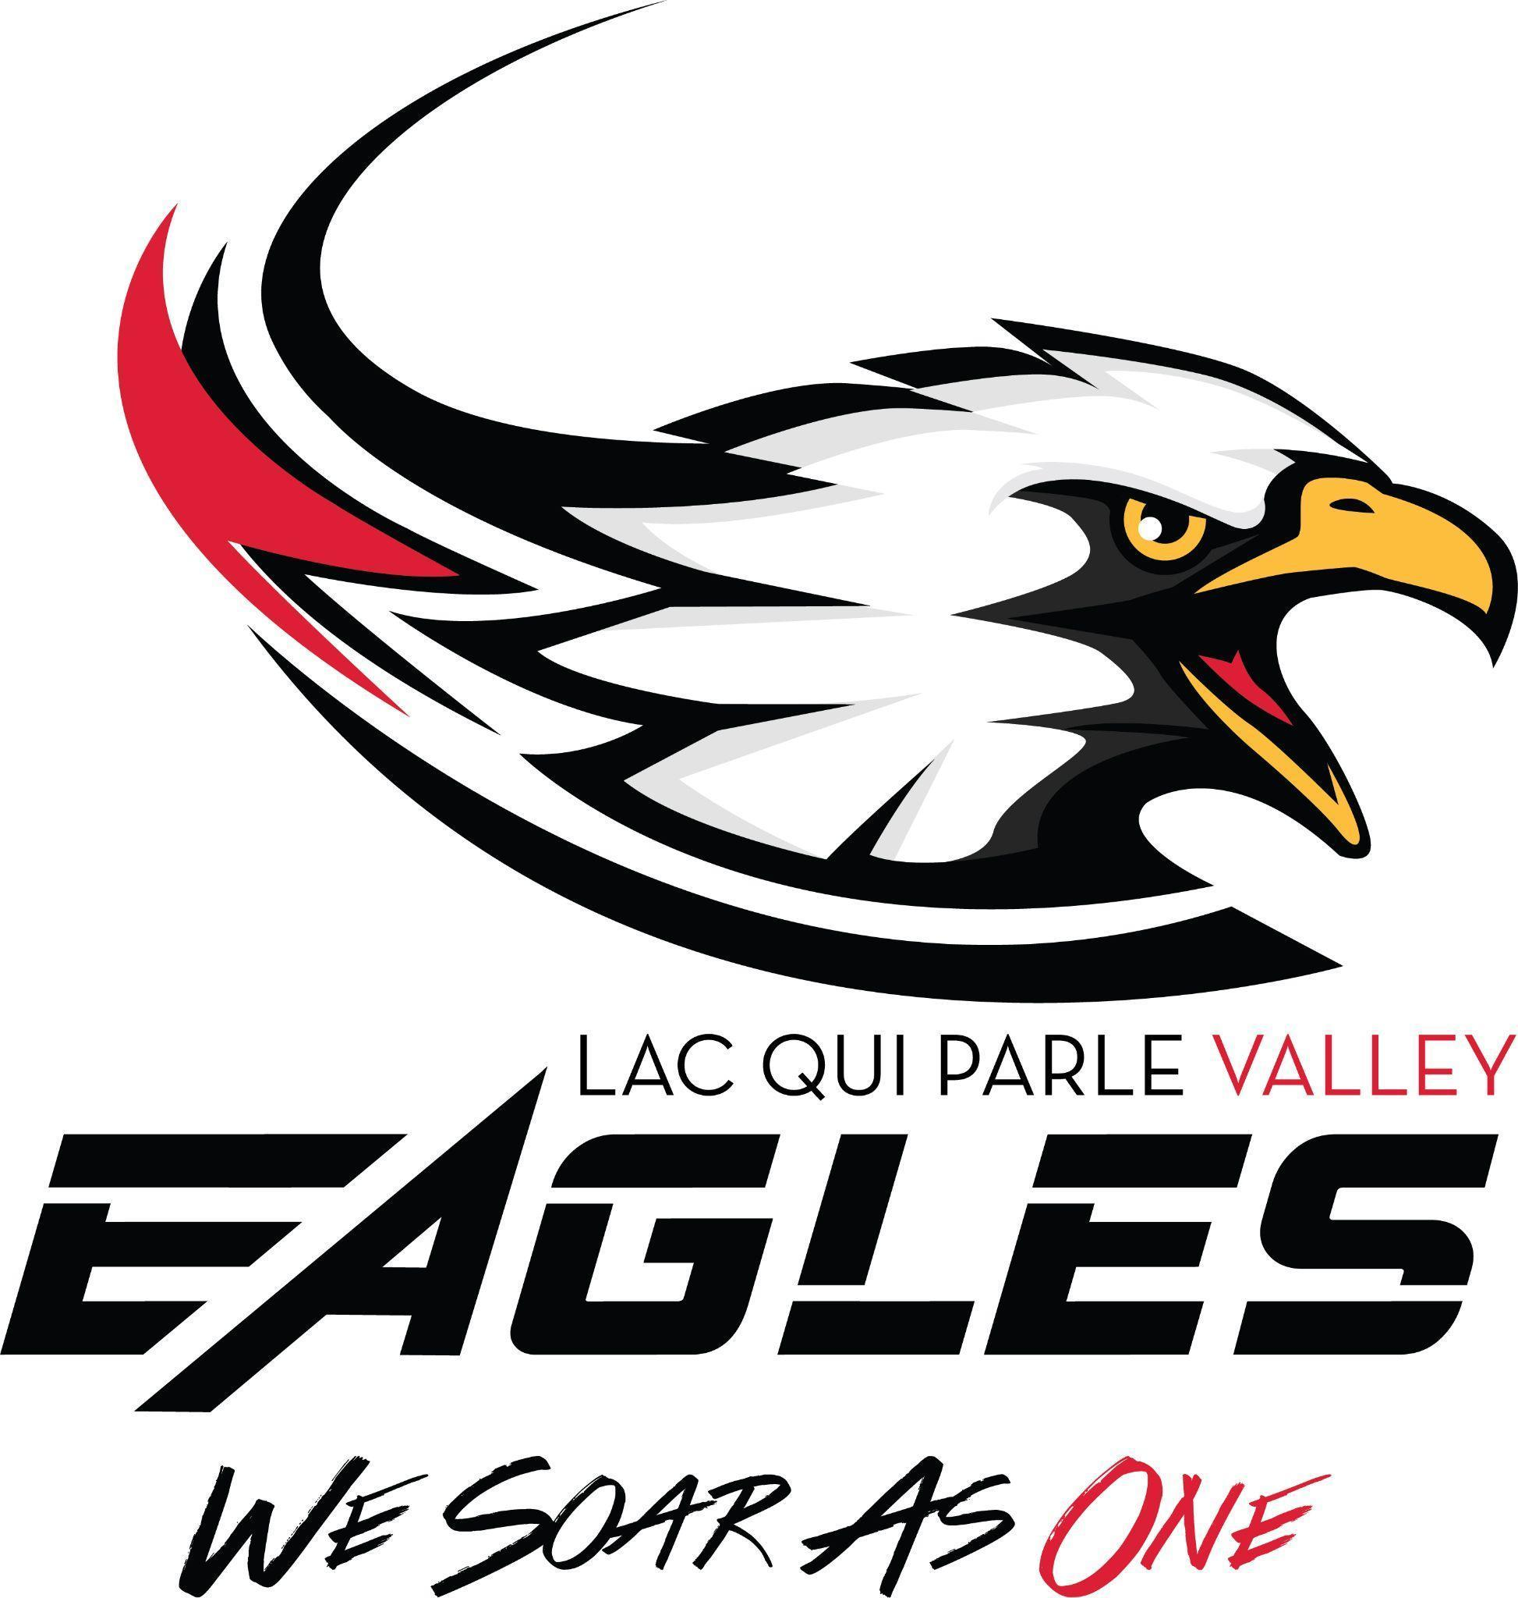

Order of Events

Coaches Meeting: 3:45 (Finish Line)
Field Events Start Time: 4:00 p.m. Running Events Start Time: 4:45 p.m.
Pole Vault - (Boys & Girls)
Long Jump – Boys and then Girls will follow 4x800 - Girls/Boys
Triple Jump – Girls and then Boys to follow 100 Hurdles – Girls
High Jump – Boys and then Girls to follow 110 Hurdles - Boys
Shot (Boys & Girls) 100 – Girls/Boys
Discuss (Girls & Boys) 4x200 – Girls/Boys
1600 – Girls/Boys
4x100 – Girls/Boys
Please let athletes know that if they could help with raking or running the tape measure, it would be greatly appreciated!

400 – Girls/Boys
300 IH – Girls/Boys
800 – Girls/Boys
200 – Girls/Boys
3200 Run - Girls/Boys
4x400 - Girls/Boys
4x100 Co-Ed Throwers Banana Relay

