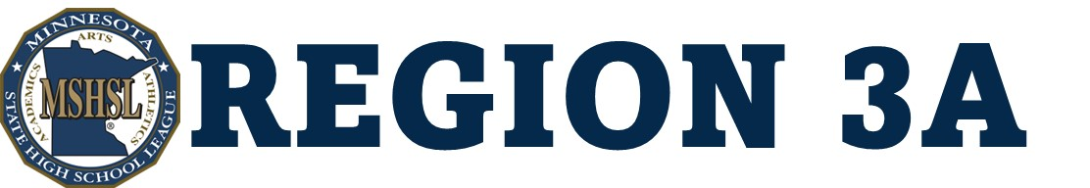

Saturday, February 28, 2026
Section 3A Boys’ Basketball
at Montevideo High School
11:00 a.m. - LQPV vs. CMCS  12:30 p.m. - MACCRAY vs. RCW | 2:30 p.m. - YME vs. Dawson-Boyd  4:00 p.m. - Minneota vs. Wabasso
ALL TICKETS WILL BE SOLD DIGITALLY
NO CASH SALES AT THE DOOR
Card Readers Available at the Door
One Ticket is Good for All Games

You Will Receive an Email
With Your Tickets
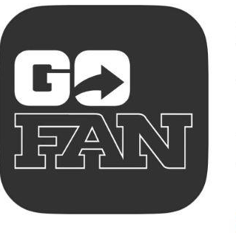
Redeem at the Door For Entrance
Store Your Tickets
Get the GoFan App

